**WEBSITE AUDIT REPORT**

<https://aligners.pk/>

As on 14 OCT 2024, I have conducted an seo audit for the website: <https://aligners.pk/>

SITE AUDIT for

URL : https://aligners.pk/ (site is secured)

HTTPS (SSL) is Secure.

**Technical Audit**

IP Address:  [173.236.247.40](http://173.236.247.40/)

Server location:  CALIFORNIA, Brea

**Google Page rank:**

2/10 (Low Quality, Need to post relative data, with alt text in

image, HTML tag, etc.)

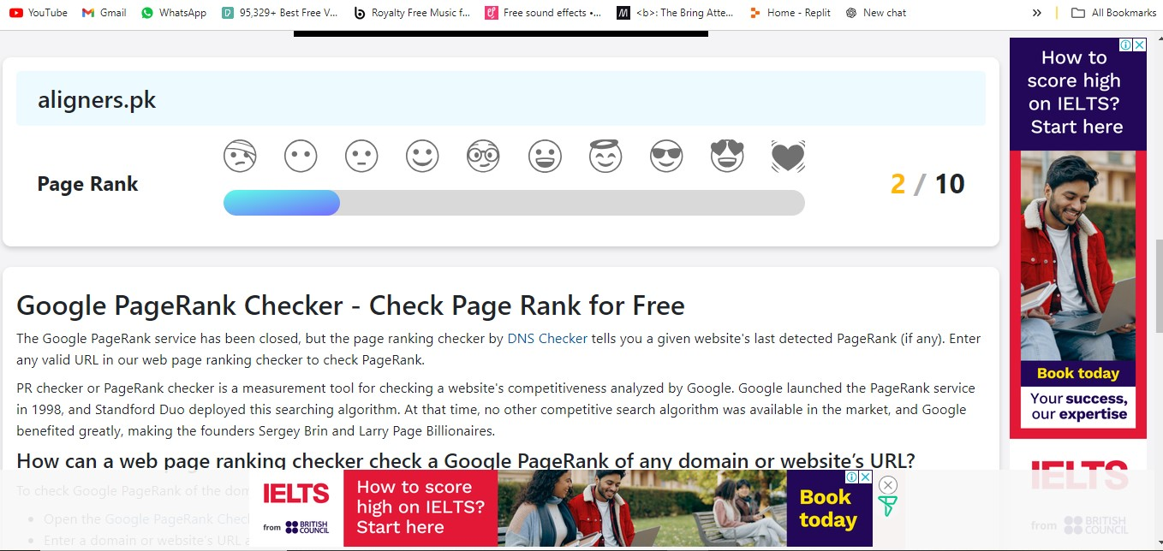

**Google Mobile Page Speed Score:**

47% (should have 90-100)

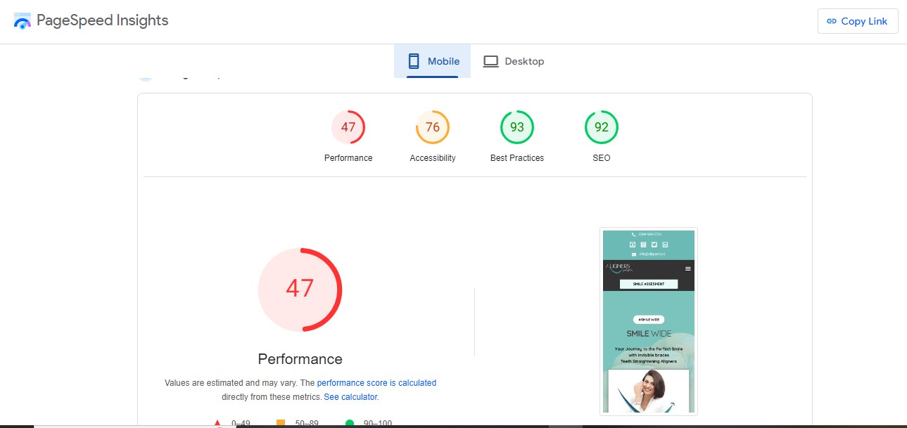

**Google Desktop Page Speed Score:**

75% (should have 90-100)

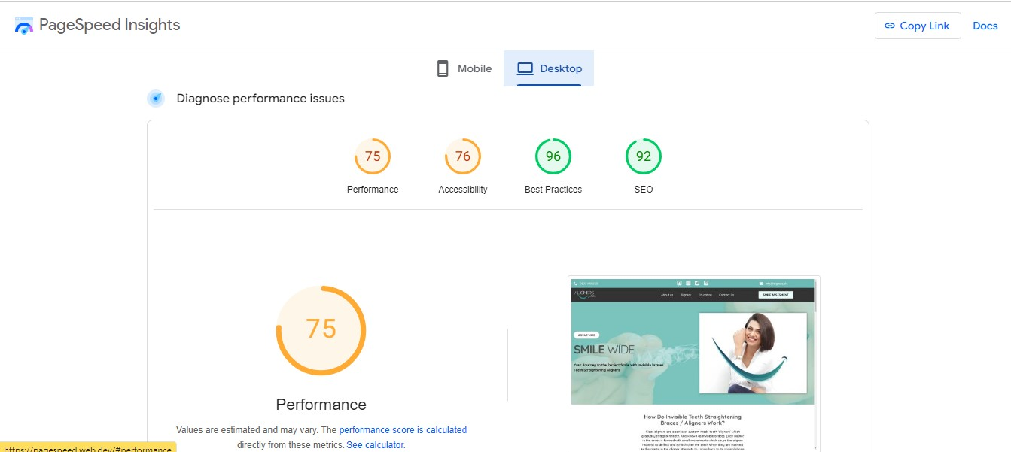

**External Backlinks:**

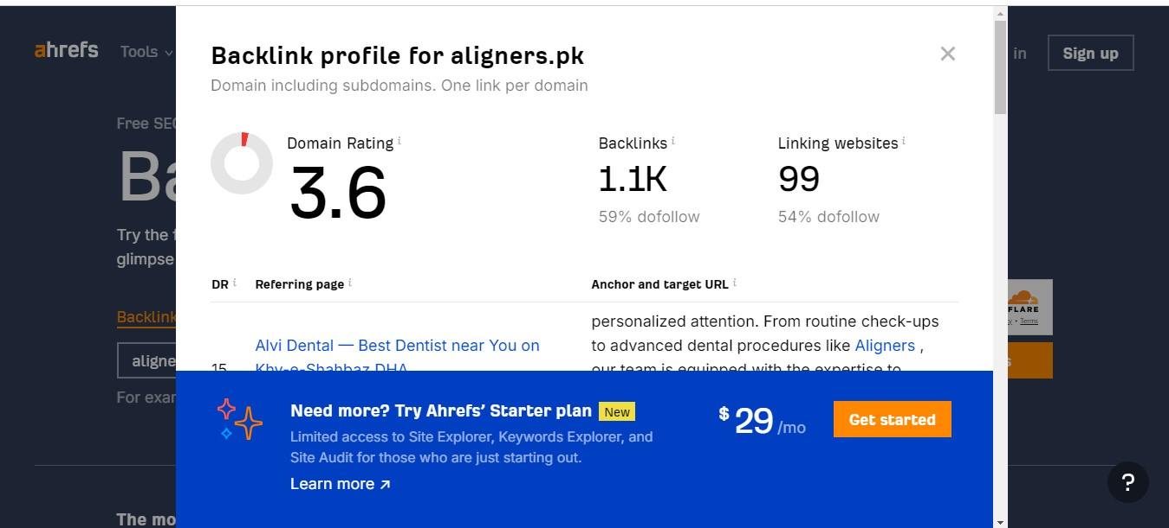

**Site Health: 67.3%**

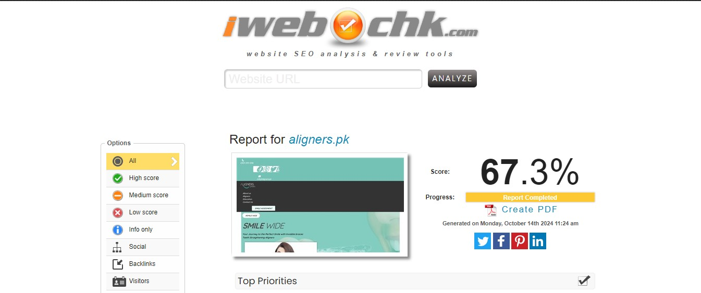

**Monthly Organic Traffic:**

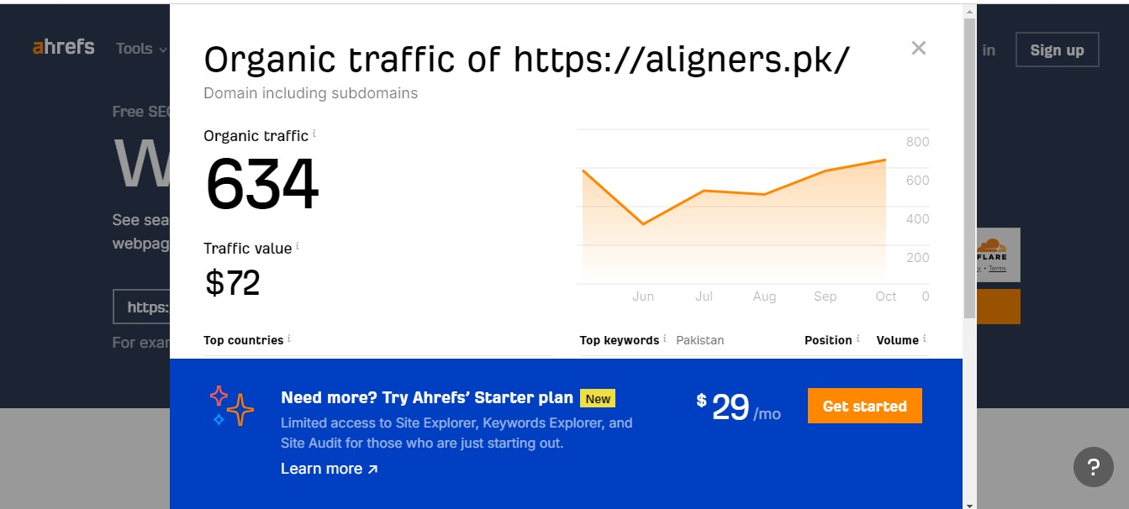

**Avg. Page (HTML) Load Speed: - 2.5 s**

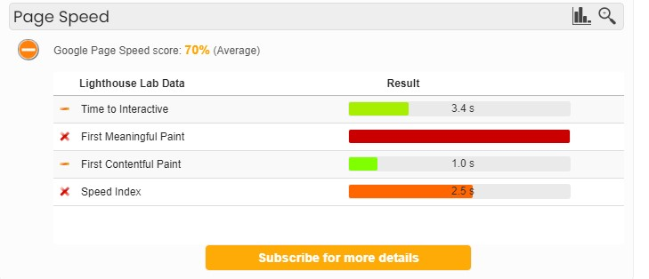

Site is Mobile Responsive.

**Tags And Description**

META TAGS

TITLE META TAG:

*"Aligners Pakistan - Your Perfect Smile with Invisible braces"*

DESCRIPTION META TAG:

*"Aligners offers invisible braces for teeth straightening. Achieve your desired tooth alignment with our clear aligners. Get a confident smile today!"*

❖ROBOTS.TXT Is Available

<https://aligners.pk/robots.txt>

❖SITEMAP.XML:

<https://aligners.pk/sitemap_index.xml>

❖ IP REDIRECT :

your site's IP [173.236.247.40](http://173.236.247.40/) does not redirect to [aligners.pk](http://aligners.pk/)

### Spam Blacklist

your IP 173.236.247.40 is not blacklisted.

**Social Media Integration**

### Social Media Indicators

**Facebook Mentions** 0

**Twitter Recent Mentions** 0

Instagram Mentions 0